

CARE-GETE-NEWSLETTER № 3
European Urban Initiative

December 2025–May 2026

Introduction
2
The CARE-GET project continued to gain momentum over the past six months, further positioning Haskovo as an emerging centre for healthcare innovation, entrepreneurship, education and community-driven transformation in Southeast Europe. At this phase, the project has now moved decisively from strategic planning towards the active implementation of its ecosystem-building activities, combining healthcare modernisation, MedTech innovation, skills development and civic participation within a single integrated vision.
Thе 3rdedition of the CARE-GET e-newsletter highlights several key milestones achieved during the reporting period. The consortium officially launched the “CARE-GET – Programme for Entrepreneurs and Startups in Haskovo”, opening new opportunities for training, mentoring, acceleration and financial support for innovative business ideas, including specialised healthcareand MedTechinitiatives.
At European level,theCARE-GET transfer partnership gatheredinSiena,Italy, wherepartnersexchanged knowledge, explored successful innovation ecosystems and strengthened cooperation on the transfer of innovative urban solutions across Europe.
At thelocallevel, CARE-GET continued toplace citizensand communitiesat the centre ofitsdevelopment model. The project organised its first “Support Group” meeting in Haskovo, bringing together patients, caregivers, healthcare professionals and civil society organisations in an open dialogue on healthcare needs, social support and future services within the planned MedTechHub.
In parallel, communication and educational events at the Haskovo Branch of Trakia University introduced students and healthcare professionals to topics including telemedicine, digital healthcare, entrepreneurship and future career opportunities in the region.
These activities reflect the growing operational dimension of CARE-GET — a project that not only plans future transformation, but is already actively building partnerships, engaging communities, supporting innovation and laying the foundations for a sustainable MedTech and healthcare ecosystem in Haskovo and beyond.

Inthisissue:
3

CARE-GET–ProgrammeforEntrepreneursand Startups in Haskovo Officially Launched (D 7.1.2)
1
2
3
4

CARE-GETTransferPartnersMeetingin Siena (WP 9 Transfer)

CARE-GETProjectBringsTogethertheLocalCommunityinHaskovo
inItsFirst“SupportGroup”Meeting (D4.5.1)

Two-sessionworkshopat TrakiaUniversity– Haskovo Branch (D 4.5.1)

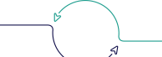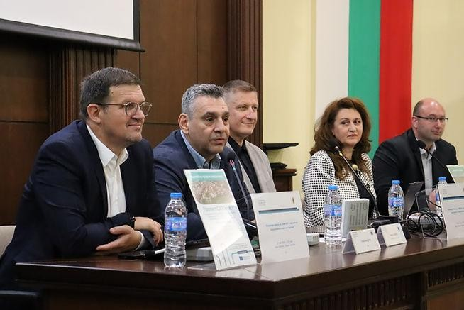01CARE-GET– Programme forEntrepreneursandStartupsin HaskovoOfficially Launched
The launch event brought together representatives of local and national institutions, businesses, educational organisations, entrepreneurs, students and stakeholders from across the region.
Participants learned more about the upcoming mentorship and accelerator programmes, including funding opportunities of:
- EUR 7,500 grants for selected entrepreneurial projects;
- EUR20,000grantsforinnovativehealthcare
andMedTechstart-ups.
4

Haskovo officially launched the “CARE-GET – Programme for Entrepreneurs and Startups in Haskovo”, designed to stimulate innovation, entrepreneurshipandbusinessdevelopment inthe region.
Theprogrammeoffers:
- practicalentrepreneurshiptraining;
- mentoring support;
- accelerator programmes;
- fundingopportunitiesforthebestinnovativeprojects.

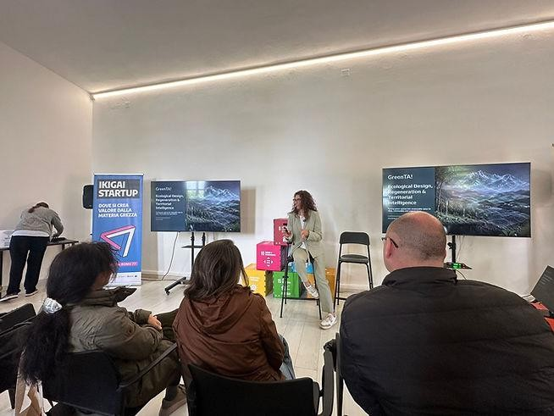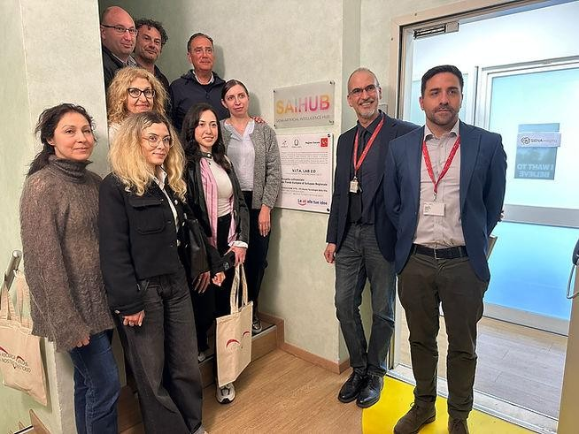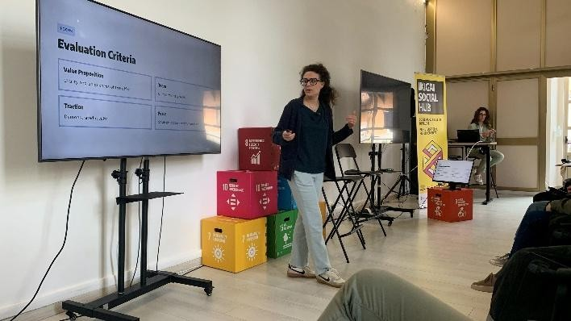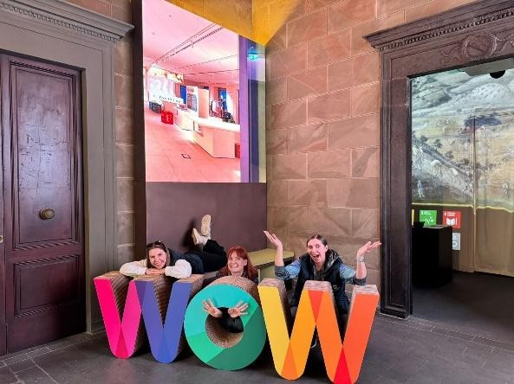02CARE-GETTransferPartnersMeetinginSiena
From6to 8May2026,CARE-GETpartnersmetinSiena,Italy,for aTransferPartnersMeetinghostedbytheMunicipality
ofSiena.
Themeetingaddressedtheexchangeofbestpractices,transferplans,implementationprogress,andfuturecooperation

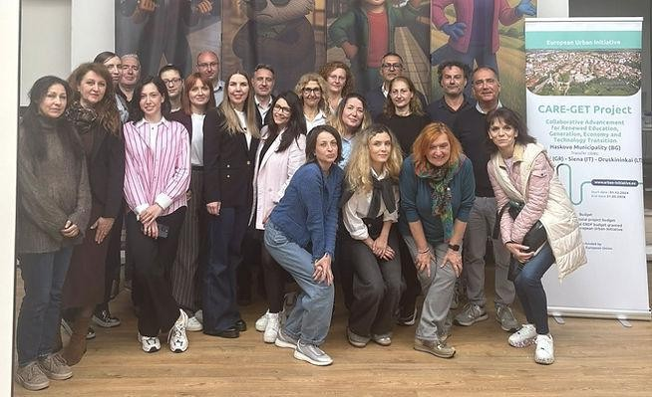
amongtransfercities.Keytopicsincludedhealthcareinnovation,digitalisation,entrepreneurshipandtechnologytransfer.

Partnersvisitedseveralleadinginnovation
andresearchcentres,including:
- ToscanaLifeSciences;
- Siena Imaging;
- IkigaiHub;
- UniversityofSienaandSantaChiara Lab.

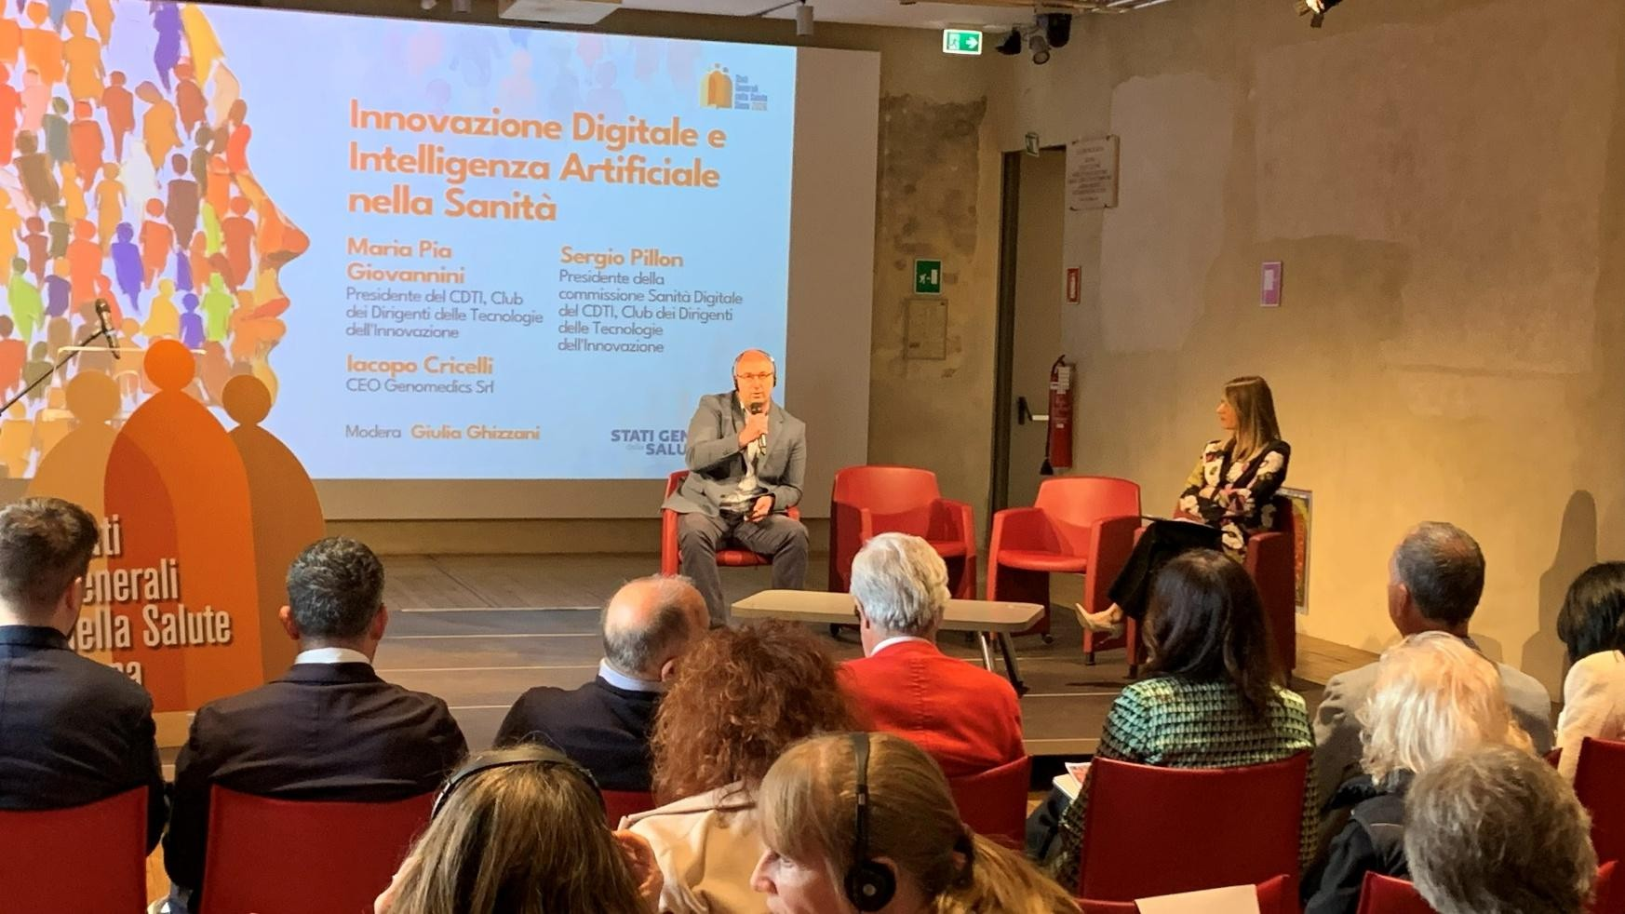02CARE-GETTransferPartnersMeetinginSiena

The CARE-GET project was also presented during the “Stati Generali della Salute” conference, dedicated to healthcare policies, digital innovation and artificial intelligence in healthcare.

03CARE-GETProjectBringsTogethertheLocalCommunityinHaskovo
inItsFirst“SupportGroup”Meeting

On20February,theBulgarianEconomic Forum,withthe supportof Trakia University –HaskovoBranch, organised the first CARE-GET “Support Group” communication event.

The meeting brought together over 25 participants, including individuals with chronic illnesses, caregivers, family members, healthcare professionals, representatives of social organisations and project partners.
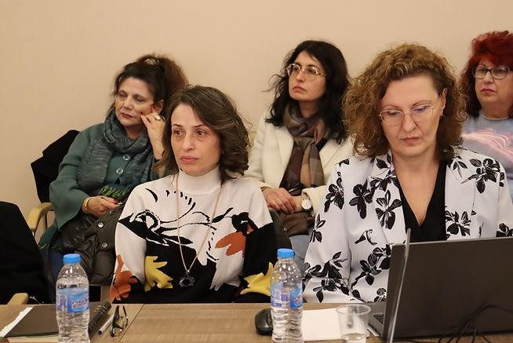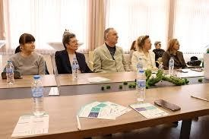The eventprovideda safe space toshare experiences, identify community needs, and discuss future healthcare and support services for the planned MedTech Hub in Haskovo.
Participants emphasised the need for regular community meetings, greater social integration, enhanced support services, and active citizen involvementin developing futurehealthcaresolutions.
The discussions produced valuable ideas that will directly inform the functional model of the MedTech Hub.

7

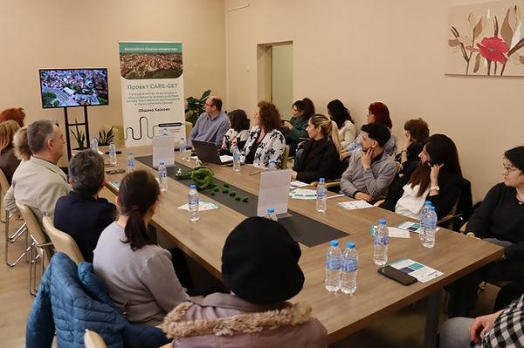

04Two-sessionworkshopat TrakiaUniversity – Haskovo Branch

On 30April, Trakia University –HaskovoBranch held a communicationevent aspart of activity D4.5.1 of the CARE-GET project, attended by over 50 participants, including students and healthcare professionals. The event addressed digital transformation in healthcare, telemedicine, remote medical assistance and career opportunities for healthcare professionals in Haskovo.
A key highlight was a live demonstration of a modern telemedicine station by Hubis Ltd., illustrating how remote healthcare technologies enhance diagnostics and support medical professionals in daily practice.
The second session included discussions with leading healthcare experts, such as Dr Ivan Ivanov, Director of the Oncology Hospital in Haskovo and Dr Mario Yanakiev, a prominent Bulgarian paediatrician.
The event concluded with a commitment to strengthen partnerships among educational institutions, healthcare providers, businesses and local authorities to support healthcare innovation and regional development.

8

04Two-sessionworkshopatTrakiaUniversity–HaskovoBranch

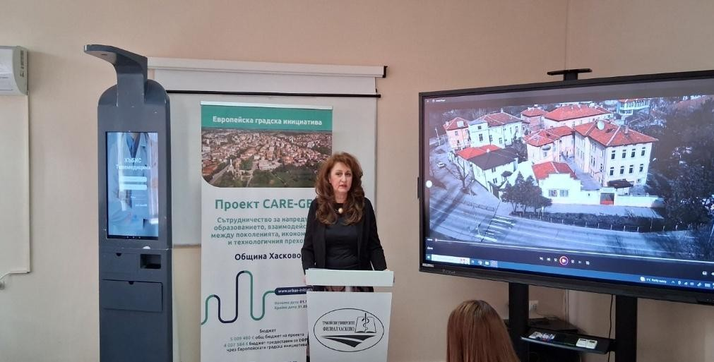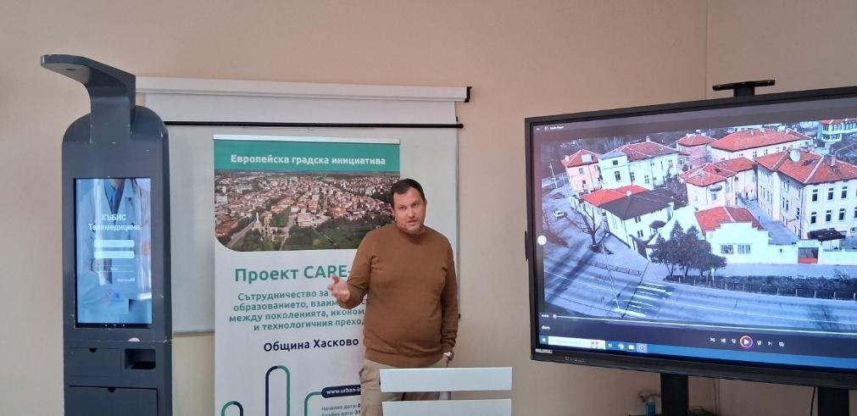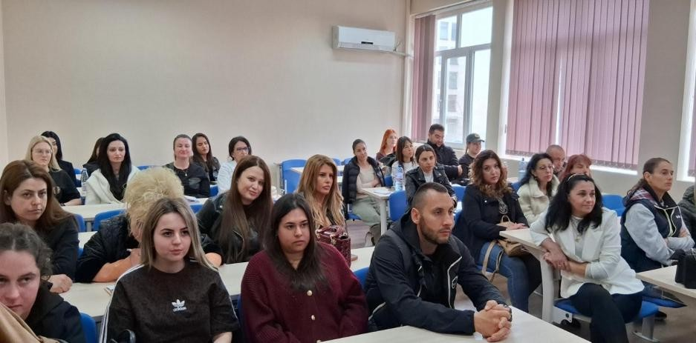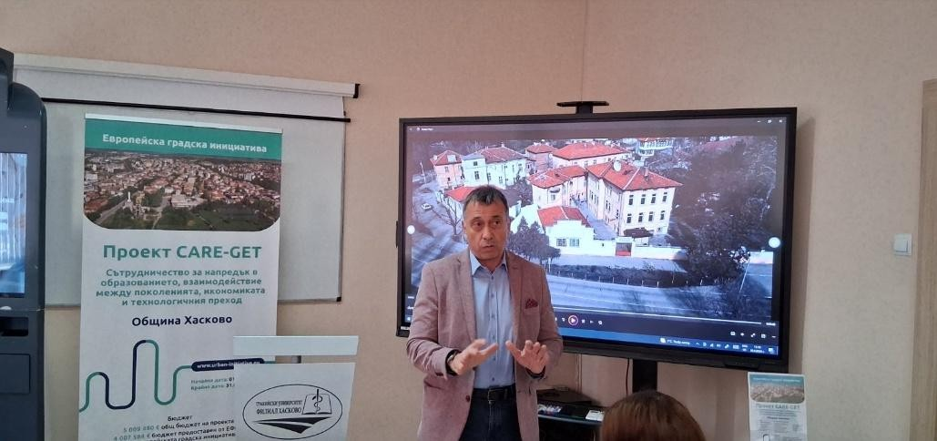

9

Leadpartnerofthe
CARE-GETproject

MunicipalityofHaskovo, BULGARIA

Formoreinformation,visithttps://haskovo-hub.bg/novini/

10

